Homework Three
--------------------------------------------------------------------------------------------------------------------------------------------
Problem One
--------------------------------------------------------------------------------------------------------------------------------------------
1. Information:
I spent many time to think how to solve this Problem One by recursive, but I have tried for a long time, I still could not get the feel to solve that. Even though. I decide to begin to look for from the internet network with huge resource. At last, I Find one of the methods to solve this problem with VB in the internet network (Resource from: http://tw.knowledge.yahoo.com/question/question?qid=1106111407314), The following is the code of this program:
----------------------------------------Program code start----------------------------------------
Private Sub Form_Load()
Dim eoNum As Integer
eoNum = Val(InputBox("輸入一個正整數"))
Call anatFor(eoNum, eoNum, "")
End Sub

Private Sub anatFor(eoNum As Integer, upNum As Integer, anatNum As String)
Dim I As Integer
If eoNum = 0 Then
List1.AddItem anatNum
For I = IIf(upNum < eoNum, upNum, eoNum) To 1 Step -1
Call anatFor(eoNum - I, I, anatNum & I)
Next I
End Sub
----------------------------------------Program code end----------------------------------------
2. Running result of VB program:
If you enter 5 to the input box,
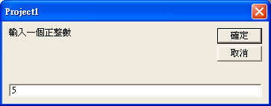
You can got the result that just like this problem one required by recursive.
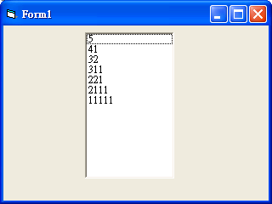
3. I try to it transform into C language (N.c):
----------------------------------------Program code start----------------------------------------
#include<stdio.h>
#include<stdlib.h>
int iif(int upnum,int eonum)
{
if(upnum<eonum)
{
return upnum;
}
else
{
return eonum;
}
}
void anatfor(int eonum,int upnum,int j)
{
int i;
if(eonum==0)
{
printf("%d\n",j);
}
for(i=iif(upnum,eonum);i>=1;i--)
{
/* getch();
printf("i=%d eonum=%d \" < eonum-i= next_eonum %d-%d=%d > < j= i & next_i j=%d }>"\n",i,eonum,eonum,i,eonum-i,j);*/
anatfor(eonum-i,i,j*10+i);
}
}
int main(void)
{
int eonum;
printf("\n---------------∮This program is-★-B9502028-★-陳敬翔-create∮---------------\nThis program can break a magnitude of number\n\nFor example:\nIf you enter \"5\", you can get those break magnitude of this number:\n5\n41\n32\n311\n2111\n11111\n\nPlease enter this number to start: ");
scanf("%d",&eonum);
anatfor(eonum,eonum,0);
getch();
return 0;
}
----------------------------------------Program code end----------------------------------------
4. Let us see whether the result is the same:
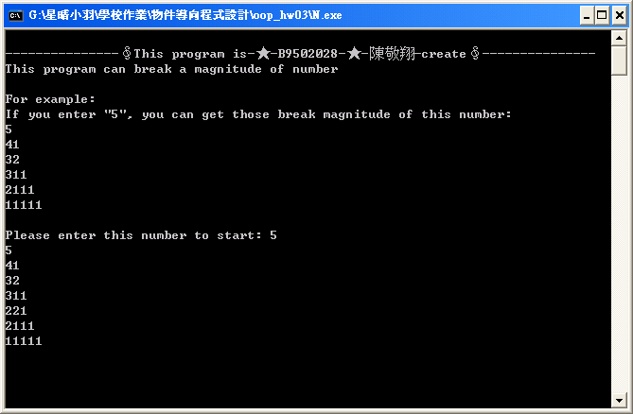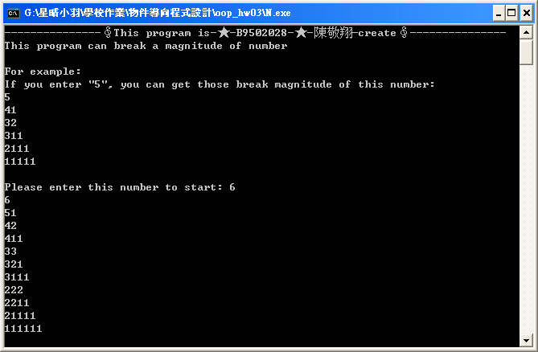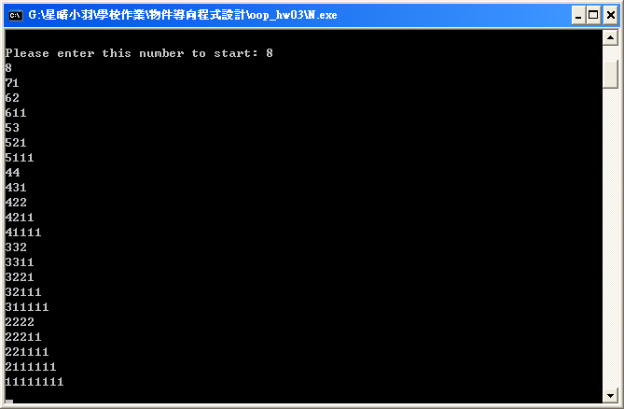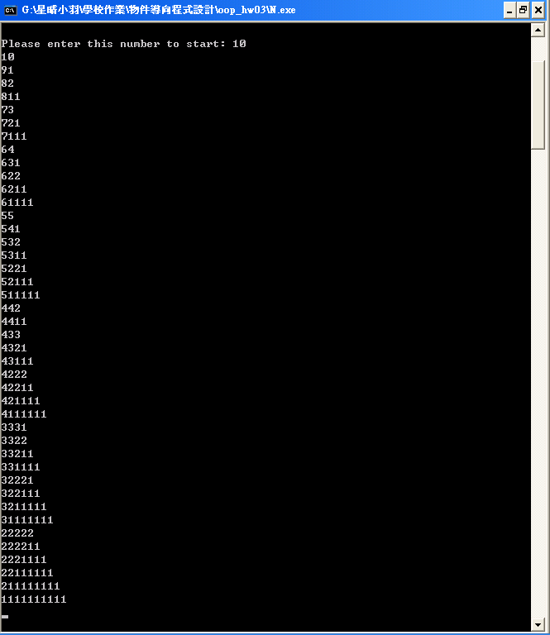
5. Principle:
I try to add some code between “ for(i=iif(upnum,eonum);i>=1;i--) ” and “ anatfor(eonum-i,i,j*10+i); ”

getch();
printf("i=%d eonum=%d \" < eonum-i= next_eonum %d-%d=%d > < j= i & next_i j=%d >\"\n",i,eonum,eonum,i,eonum-i,j);

It will print off this result of helping us watch:
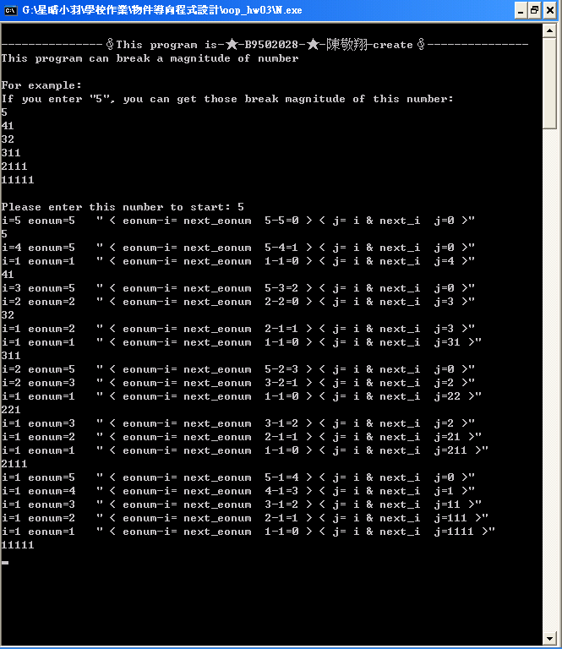
We can see that “eonum-i=next eonum”, and that means the number of “eonum” is deducted a value “I” constantly. The value “I” will be certainly smaller than number we input. Then the program will save the result that “eonum - that value” to “J”. Use recursive continued deducting the next number value “I” that smaller than this result ”eonum”, and In order to get the next value not only less but also not reduplicate that “eonum”, we get the minimum number among “I” and “next_eonum” to next “I”. Until “eonum” turn into 0 and stop this round. Print off “J” , and then let “J” turn into 0. Repeat the above movement until the remainder magnitude that we enter turn into 0, stop the program. If we meet 0, the value can not print off! Because “j*10+i”, when j=0 multiply 10, the 0 will disappear.
--------------------------------------------------------------------------------------------------------------------------------------------
Problem two
--------------------------------------------------------------------------------------------------------------------------------------------
1. Re-write the homework two to output multiplication table by using pointers:
At first, I try to use one pointer to finish the problem (multiplication_pointer_one.c):
----------------------------------------Program code start----------------------------------------
#include<stdio.h>
#include<stdlib.h>
int main()
{
short mul[9][9],i,j,*ptr; /*Use the loop " i and j " to control multiplication table.*/
printf("\n---------------∮This program is-★-B9502028-★-陳敬翔-create∮---------------\n\nThis program use pointer to print the multiplication table:\n\n");
ptr=&mul; /*And we declare a array "mul" to reserve the space of main remember recode the result.*/
for(i=0;i<9;i++) /*Then we will use a pointer "ptr" recode the mul's address*/
{
for(j=0;j<9;j++) /*mul[i,j] => [0,0],[0,1],[0,2],[0,3],[0,4],[0,5],[0,6],[0,7],[0,8],[0,9],[1,0],[1,1],[1,2],[1,3],[1,4],[1,5],[1,6],[1,7]...*/
{ /*(ptr+9*i+j) => (+0) ,(+1) ,(+2) ,(+3) ,(+4) ,(+5) ,(+6) ,(+7) ,(+8) ,(+9) ,(+10),(+11),(+12),(+13),(+14),(+15),(+16),(+17)...*/
*(ptr+9*i+j)=(i+1)*(j+1);
}
}
for(i=0;i<9;i++)
{
for(j=0;j<9;j++)
{
printf("%d*%d=%2d ",*(ptr+i),*(ptr+j),*(ptr+9*i+j)); /*Print the result!*/
}
printf("\n");
}
getch();
return 0;
}
----------------------------------------Program code end----------------------------------------
2. Resule:
Its principle is the “mul” will reserve the space of main remember, and use “ptr” calculate the value with “i” and “j”. Of course, “ptr” have to reserve the “mul[0][0]” address. The following is the diagram:
Main memery
i,j | pointer address: *(ptr+9*i+j) | value((i+1)*(j+1)) | array address: mul[i][j]
.  .  . | .  .  . | .  .  . | .  .  .
i = 0 , j = 0 | ptr => | 1 | <= mul[0][0]
i = 0 , j = 1 | ptr + 1(short = 2bytes) => | 2 | <= mul[0][1]
i = 0 , j = 2 | ptr + 2 => | 3 | <= mul[0][2]
i = 0 , j = 3 | ptr + 3 => | 4 | <= mul[0][3]
i = 0 , j = 4 | ptr + 4 => | 5 | <= mul[0][4]
i = 0 , j = 5 | ptr + 5 => | 6 | <= mul[0][5]
i = 0 , j = 6 | ptr + 6 => | 7 | <= mul[0][6]
i = 0 , j = 7 | ptr + 7 => | 8 | <= mul[0][7]
i = 0 , j = 8 | ptr + 8 => | 9 | <= mul[0][8]
i = 1 , j = 0 | ptr + 9 => | 2 | <= mul[1][0]
i = 1 , j = 1 | ptr + 10 => | 4 | <= mul[1][1]
i = 1 , j = 2 | ptr + 11 => | 6 | <= mul[1][2]
i = 1 , j = 3 | ptr + 12 => | 8 | <= mul[1][3]
i = 1 , j = 4 | ptr + 13 => | 10 | <= mul[1][4]
i = 1 , j = 5 | ptr + 14 => | 12 | <= mul[1][5]
i = 1 , j = 6 | ptr + 15 => | 14 | <= mul[1][6]
i = 1 , j = 7 | ptr + 16 => | 16 | <= mul[1][7]
.  .  . | .  .  . | .  .  . | .  .  .
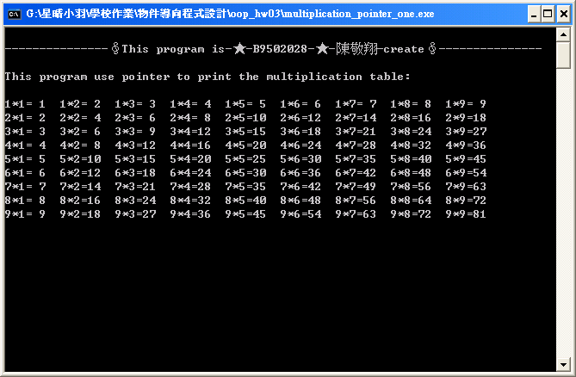
But The problem demands to use “pointers” to do, I think I can do that use two dimension pointers (multiplication_pointer_two.c):
----------------------------------------Program code start----------------------------------------
#include<stdio.h>
#include<stdlib.h>
int main()
{
short mul[9][9],i,j,*ptr[9]; /*Use the loop " i and j " to control multiplication table.*/
printf("\n---------------∮This program is-★-B9502028-★-陳敬翔-create∮---------------\n\nThis program use pointer to print the multiplication table:\n\n");
for(i=0;i<9;i++) /*And we declare a array "mul" to reserve the space of main remember recode the multiplication result.*/
{
ptr[i]=&mul[i]; /*Then we will use nine pointers "ptr[9]" to recode the nine "mul[9]"s' one dimension addresses*/
}
for(i=0;i<9;i++)
{
for(j=0;j<9;j++) /*mul[i,j] => [0,0] ,[0,1] ,[0,2] ,[0,3] ,[0,4] ,[0,5] ,[0,6] ,[0,7] ,[0,8] ,[0,9] ,[1,0] ,[1,1] ,[1,2] ,[1,3] ,[1,4] ,[1,5] ,[1,6] ,[1,7] ...*/
{ /*(ptr[i]+j)=> ([0]+0),([0]+1),([0]+2),([0]+3),([0]+4),([0]+5),([0]+6),([0]+7),([0]+8),([0]+9),([1]+0),([1]+1),([1]+2),([1]+3),([1]+4),([1]+5),([1]+6),([1]+7)...*/
*(ptr[i]+j)=(i+1)*(j+1);
}
}
for(i=0;i<9;i++)
{
for(j=0;j<9;j++)
{
printf("%d*%d=%2d ",*(ptr[i]),*(ptr[0]+j),*(ptr[i]+j)); /*Print the result!*/
}
printf("\n");
}
getch();
return 0;
}
----------------------------------------Program code end----------------------------------------
It is a simple way to solve this problem. I can set the one dimension of “mul” to every dimension of “ptr”. because “mul” have already reserved the space of main memory, and every dimension of “*ptr[]” type are fluctuation array! Use that characteristic, I can print off the multiplication table with the pointer easily, and the “*ptr[]” type can be regarded as two pointer. Accord with the demands for problem:

Main memery
i,j | pointer address: *(ptr[i]+j) | value((i+1)*(j+1)) | array address: mul[i][j]
.  .  . | .  .  . | .  .  . | .  .  .
i = 0 , j = 0 | ptr[0] => | 1 | <= mul[0][0]
i = 0 , j = 1 | ptr[0] + 1 => | 2 | <= mul[0][1]
i = 0 , j = 2 | ptr[0] + 2 => | 3 | <= mul[0][2]
i = 0 , j = 3 | ptr[0] + 3 => | 4 | <= mul[0][3]
i = 0 , j = 4 | ptr[0] + 4 => | 5 | <= mul[0][4]
i = 0 , j = 5 | ptr[0] + 5 => | 6 | <= mul[0][5]
i = 0 , j = 6 | ptr[0] + 6 => | 7 | <= mul[0][6]
i = 0 , j = 7 | ptr[0] + 7 => | 8 | <= mul[0][7]
i = 0 , j = 8 | ptr[0] + 8 => | 9 | <= mul[0][8]
i = 1 , j = 0 | ptr[1] => | 2 | <= mul[1][0]
i = 1 , j = 1 | ptr[1] + 1 => | 4 | <= mul[1][1]
i = 1 , j = 2 | ptr[1] + 2 => | 6 | <= mul[1][2]
i = 1 , j = 3 | ptr[1] + 3 => | 8 | <= mul[1][3]
i = 1 , j = 4 | ptr[1] + 4 => | 10 | <= mul[1][4]
i = 1 , j = 5 | ptr[1] + 5 => | 12 | <= mul[1][5]
i = 1 , j = 6 | ptr[1] + 6 => | 14 | <= mul[1][6]
i = 1 , j = 7 | ptr[1] + 7 => | 16 | <= mul[1][7]
.  .  . | .  .  . | .  .  . | .  .  .

Simple concept:
